 



Database Programming with SQL

* 1. : Final Project Database Creation Practice Activities

# Objectives

* + - Develop and apply a strategy for testing that a database functions as designed.

# Try It / Solve It

1. Complete Parts 1-5 of the Final Project for at least one of the sample entity relationship diagrams

*and* for the entity relationship diagram you completed in the database design course.

Part 1: Create Table diagram from ERD Part 2: Write and run scripts to create tables Part 3: Insert sample data

Part 4: Test database

Part 5: Prepare final project presentation

1. Present your Final Project.

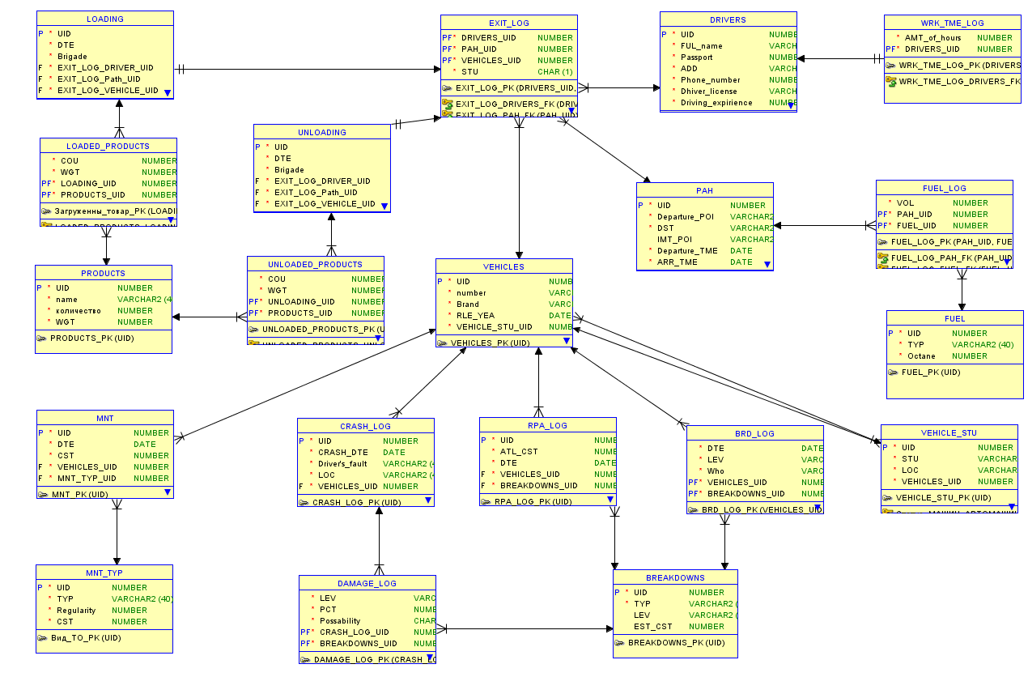

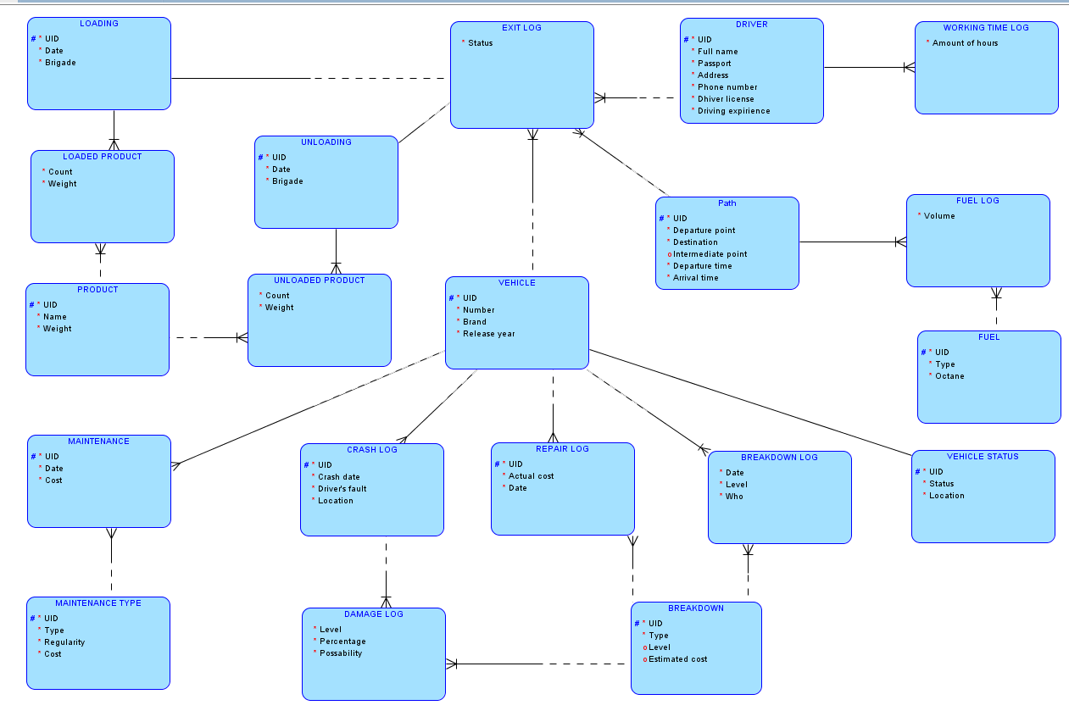

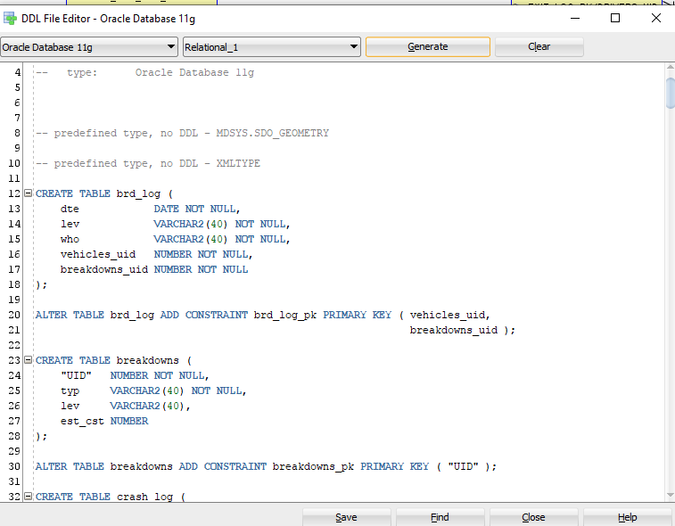

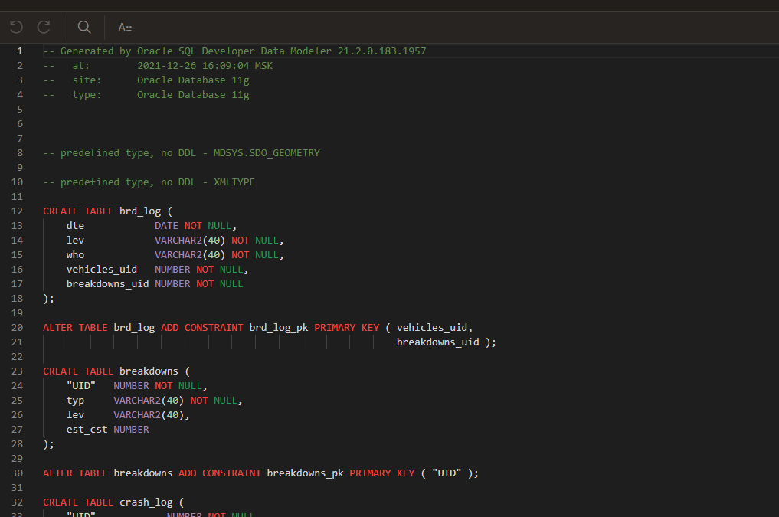

-- Generated by Oracle SQL Developer Data Modeler 21.2.0.183.1957

-- at: 2021-12-26 16:09:04 MSK

-- site: Oracle Database 11g

-- type: Oracle Database 11g

-- predefined type, no DDL - MDSYS.SDO_GEOMETRY

-- predefined type, no DDL - XMLTYPE

CREATE TABLE brd_log (

dte DATE NOT NULL,

lev VARCHAR2(40) NOT NULL,

who VARCHAR2(40) NOT NULL,

vehicles_uid NUMBER NOT NULL,

breakdowns_uid NUMBER NOT NULL

);

ALTER TABLE brd_log ADD CONSTRAINT brd_log_pk PRIMARY KEY ( vehicles_uid,

breakdowns_uid );

CREATE TABLE breakdowns (

"UID" NUMBER NOT NULL,

typ VARCHAR2(40) NOT NULL,

lev VARCHAR2(40),

est_cst NUMBER

);

ALTER TABLE breakdowns ADD CONSTRAINT breakdowns_pk PRIMARY KEY ( "UID" );

CREATE TABLE crash_log (

"UID" NUMBER NOT NULL,

crash_dte DATE NOT NULL,

"Drivers_fault" VARCHAR2(40) NOT NULL,

loc VARCHAR2(40) NOT NULL,

vehicles_uid NUMBER NOT NULL

);

ALTER TABLE crash_log ADD CONSTRAINT crash_log_pk PRIMARY KEY ( "UID" );

CREATE TABLE damage_log (

lev VARCHAR2(40) NOT NULL,

pct NUMBER NOT NULL,

possability CHAR(1) NOT NULL,

crash_log_uid NUMBER NOT NULL,

breakdowns_uid NUMBER NOT NULL

);

ALTER TABLE damage_log ADD CONSTRAINT damage_log_pk PRIMARY KEY ( crash_log_uid,

breakdowns_uid );

CREATE TABLE drivers (

"UID" NUMBER NOT NULL,

ful_name VARCHAR2(40) NOT NULL,

passport NUMBER NOT NULL,

"ADD" VARCHAR2(40) NOT NULL,

phone_number NUMBER NOT NULL,

dhiver_license VARCHAR2(40) NOT NULL,

driving_expirience NUMBER NOT NULL

);

ALTER TABLE drivers ADD CONSTRAINT drivers_pk PRIMARY KEY ( "UID" );

CREATE TABLE exit_log (

drivers_uid NUMBER NOT NULL,

pah_uid NUMBER NOT NULL,

vehicles_uid NUMBER NOT NULL,

stu CHAR(1) NOT NULL

);

ALTER TABLE exit_log

ADD CONSTRAINT exit_log_pk PRIMARY KEY ( drivers_uid,

pah_uid,

vehicles_uid );

CREATE TABLE fuel (

"UID" NUMBER NOT NULL,

typ VARCHAR2(40) NOT NULL,

octane NUMBER NOT NULL

);

ALTER TABLE fuel ADD CONSTRAINT fuel_pk PRIMARY KEY ( "UID" );

CREATE TABLE fuel_log (

vol NUMBER NOT NULL,

pah_uid NUMBER NOT NULL,

fuel_uid NUMBER NOT NULL

);

ALTER TABLE fuel_log ADD CONSTRAINT fuel_log_pk PRIMARY KEY ( pah_uid,

fuel_uid );

CREATE TABLE loaded_products (

cou NUMBER NOT NULL,

wgt NUMBER NOT NULL,

loading_uid NUMBER NOT NULL,

products_uid NUMBER NOT NULL

);

ALTER TABLE loaded_products ADD CONSTRAINT ���_�� PRIMARY KEY ( loading_uid,

products_uid );

CREATE TABLE loading (

"UID" NUMBER NOT NULL,

dte DATE NOT NULL,

brigade VARCHAR2(40) NOT NULL,

exit_log_driver_uid NUMBER NOT NULL,

exit_log_path_uid NUMBER NOT NULL,

exit_log_vehicle_uid NUMBER NOT NULL

);

CREATE UNIQUE INDEX ���idx ON

loading (

exit_log_driver_uid

ASC,

exit_log_path_uid

ASC,

exit_log_vehicle_uid

ASC );

ALTER TABLE loading ADD CONSTRAINT loading_pk PRIMARY KEY ( "UID" );

CREATE TABLE mnt (

"UID" NUMBER NOT NULL,

dte DATE NOT NULL,

cst NUMBER NOT NULL,

vehicles_uid NUMBER NOT NULL,

mnt_typ_uid NUMBER NOT NULL

);

ALTER TABLE mnt ADD CONSTRAINT mnt_pk PRIMARY KEY ( "UID" );

CREATE TABLE mnt_typ (

"UID" NUMBER NOT NULL,

typ VARCHAR2(40) NOT NULL,

regularity NUMBER NOT NULL,

cst NUMBER NOT NULL

);

ALTER TABLE mnt_typ ADD CONSTRAINT �_�k PRIMARY KEY ( "UID" );

CREATE TABLE pah (

"UID" NUMBER NOT NULL,

departure_poi VARCHAR2(40) NOT NULL,

dst VARCHAR2(40) NOT NULL,

imt_poi VARCHAR2(40),

departure_tme DATE NOT NULL,

arr_tme DATE NOT NULL

);

ALTER TABLE pah ADD CONSTRAINT pah_pk PRIMARY KEY ( "UID" );

CREATE TABLE products (

"UID" NUMBER NOT NULL,

name VARCHAR2(40) NOT NULL,

��� NUMBER NOT NULL,

wgt NUMBER NOT NULL

);

ALTER TABLE products ADD CONSTRAINT products_pk PRIMARY KEY ( "UID" );

CREATE TABLE rpa_log (

"UID" NUMBER NOT NULL,

atl_cst NUMBER NOT NULL,

dte DATE NOT NULL,

vehicles_uid NUMBER NOT NULL,

breakdowns_uid NUMBER NOT NULL

);

ALTER TABLE rpa_log ADD CONSTRAINT rpa_log_pk PRIMARY KEY ( "UID" );

CREATE TABLE unloaded_products (

cou NUMBER NOT NULL,

wgt NUMBER NOT NULL,

unloading_uid NUMBER NOT NULL,

products_uid NUMBER NOT NULL

);

ALTER TABLE unloaded_products ADD CONSTRAINT unloaded_products_pk PRIMARY KEY ( unloading_uid,

products_uid );

CREATE TABLE unloading (

"UID" NUMBER NOT NULL,

dte DATE NOT NULL,

brigade VARCHAR2(40) NOT NULL,

exit_log_driver_uid NUMBER NOT NULL,

exit_log_path_uid NUMBER NOT NULL,

exit_log_vehicle_uid NUMBER NOT NULL

);

CREATE UNIQUE INDEX ���idx ON

unloading (

exit_log_driver_uid

ASC,

exit_log_path_uid

ASC,

exit_log_vehicle_uid

ASC );

ALTER TABLE unloading ADD CONSTRAINT unloading_pk PRIMARY KEY ( "UID" );

CREATE TABLE vehicle_stu (

"UID" NUMBER NOT NULL,

stu VARCHAR2(40) NOT NULL,

loc VARCHAR2(40) NOT NULL,

vehicles_uid NUMBER NOT NULL

);

CREATE UNIQUE INDEX ����_idx ON

vehicle_stu (

vehicles_uid

ASC );

ALTER TABLE vehicle_stu ADD CONSTRAINT vehicle_stu_pk PRIMARY KEY ( "UID" );

CREATE TABLE vehicles (

"UID" NUMBER NOT NULL,

"number" VARCHAR2(40) NOT NULL,

brand VARCHAR2(40) NOT NULL,

rle_yea DATE NOT NULL,

vehicle_stu_uid NUMBER NOT NULL

);

CREATE UNIQUE INDEX ����__idx ON

vehicles (

vehicle_stu_uid

ASC );

ALTER TABLE vehicles ADD CONSTRAINT vehicles_pk PRIMARY KEY ( "UID" );

CREATE TABLE wrk_tme_log (

amt_of_hours NUMBER NOT NULL,

drivers_uid NUMBER NOT NULL

);

ALTER TABLE wrk_tme_log ADD CONSTRAINT wrk_tme_log_pk PRIMARY KEY ( drivers_uid );

ALTER TABLE brd_log

ADD CONSTRAINT brd_log_breakdowns_fk FOREIGN KEY ( breakdowns_uid )

REFERENCES breakdowns ( "UID" );

ALTER TABLE brd_log

ADD CONSTRAINT brd_log_vehicles_fk FOREIGN KEY ( vehicles_uid )

REFERENCES vehicles ( "UID" );

ALTER TABLE crash_log

ADD CONSTRAINT crash_log_vehicles_fk FOREIGN KEY ( vehicles_uid )

REFERENCES vehicles ( "UID" );

ALTER TABLE damage_log

ADD CONSTRAINT damage_log_breakdowns_fk FOREIGN KEY ( breakdowns_uid )

REFERENCES breakdowns ( "UID" );

ALTER TABLE damage_log

ADD CONSTRAINT damage_log_crash_log_fk FOREIGN KEY ( crash_log_uid )

REFERENCES crash_log ( "UID" );

ALTER TABLE exit_log

ADD CONSTRAINT exit_log_drivers_fk FOREIGN KEY ( drivers_uid )

REFERENCES drivers ( "UID" );

ALTER TABLE exit_log

ADD CONSTRAINT exit_log_pah_fk FOREIGN KEY ( pah_uid )

REFERENCES pah ( "UID" );

ALTER TABLE exit_log

ADD CONSTRAINT exit_log_vehicles_fk FOREIGN KEY ( vehicles_uid )

REFERENCES vehicles ( "UID" );

ALTER TABLE fuel_log

ADD CONSTRAINT fuel_log_fuel_fk FOREIGN KEY ( fuel_uid )

REFERENCES fuel ( "UID" );

ALTER TABLE fuel_log

ADD CONSTRAINT fuel_log_pah_fk FOREIGN KEY ( pah_uid )

REFERENCES pah ( "UID" );

ALTER TABLE loaded_products

ADD CONSTRAINT loaded_products_loading_fk FOREIGN KEY ( loading_uid )

REFERENCES loading ( "UID" );

ALTER TABLE loaded_products

ADD CONSTRAINT loaded_products_products_fk FOREIGN KEY ( products_uid )

REFERENCES products ( "UID" );

ALTER TABLE loading

ADD CONSTRAINT loading_exit_log_fk FOREIGN KEY ( exit_log_driver_uid,

exit_log_path_uid,

exit_log_vehicle_uid )

REFERENCES exit_log ( drivers_uid,

pah_uid,

vehicles_uid );

ALTER TABLE mnt

ADD CONSTRAINT mnt_mnt_typ_fk FOREIGN KEY ( mnt_typ_uid )

REFERENCES mnt_typ ( "UID" );

ALTER TABLE mnt

ADD CONSTRAINT mnt_vehicles_fk FOREIGN KEY ( vehicles_uid )

REFERENCES vehicles ( "UID" );

ALTER TABLE rpa_log

ADD CONSTRAINT rpa_log_breakdowns_fk FOREIGN KEY ( breakdowns_uid )

REFERENCES breakdowns ( "UID" );

ALTER TABLE rpa_log

ADD CONSTRAINT rpa_log_vehicles_fk FOREIGN KEY ( vehicles_uid )

REFERENCES vehicles ( "UID" );

ALTER TABLE unloaded_products

ADD CONSTRAINT unloaded_products_products_fk FOREIGN KEY ( products_uid )

REFERENCES products ( "UID" );

ALTER TABLE unloaded_products

ADD CONSTRAINT unloaded_products_unloading_fk FOREIGN KEY ( unloading_uid )

REFERENCES unloading ( "UID" );

ALTER TABLE unloading

ADD CONSTRAINT unloading_exit_log_fk FOREIGN KEY ( exit_log_driver_uid,

exit_log_path_uid,

exit_log_vehicle_uid )

REFERENCES exit_log ( drivers_uid,

pah_uid,

vehicles_uid );

ALTER TABLE wrk_tme_log

ADD CONSTRAINT wrk_tme_log_drivers_fk FOREIGN KEY ( drivers_uid )

REFERENCES drivers ( "UID" );

-- Error - Foreign Key ������_�����FK has no columns

-- Error - Foreign Key �����������_FK has no columns

-- Oracle SQL Developer Data Modeler Summary Report:

--

-- CREATE TABLE 20

-- CREATE INDEX 4

-- ALTER TABLE 41

-- CREATE VIEW 0

-- ALTER VIEW 0

-- CREATE PACKAGE 0

-- CREATE PACKAGE BODY 0

-- CREATE PROCEDURE 0

-- CREATE FUNCTION 0

-- CREATE TRIGGER 0

-- ALTER TRIGGER 0

-- CREATE COLLECTION TYPE 0

-- CREATE STRUCTURED TYPE 0

-- CREATE STRUCTURED TYPE BODY 0

-- CREATE CLUSTER 0

-- CREATE CONTEXT 0

-- CREATE DATABASE 0

-- CREATE DIMENSION 0

-- CREATE DIRECTORY 0

-- CREATE DISK GROUP 0

-- CREATE ROLE 0

-- CREATE ROLLBACK SEGMENT 0

-- CREATE SEQUENCE 0

-- CREATE MATERIALIZED VIEW 0

-- CREATE MATERIALIZED VIEW LOG 0

-- CREATE SYNONYM 0

-- CREATE TABLESPACE 0

-- CREATE USER 0

--

-- DROP TABLESPACE 0

-- DROP DATABASE 0

--

-- REDACTION POLICY 0

--

-- ORDS DROP SCHEMA 0

-- ORDS ENABLE SCHEMA 0

-- ORDS ENABLE OBJECT 0

--

-- ERRORS 2

-- WARNINGS 0

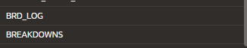

Copyright © 2020, Oracle and/or its affiliates. All rights reserved. Oracle and Java are registered trademarks of Oracle and/or its affiliates. Other names may be trademarks of their respective owners.